* Introduction
  + Article written by Robert Marquand for the Christian Science Monitor.
  + It reacts to a French law that banned the words “Facebook” and “Twitter” in the French Medias.
* 1. What do the media experts say about this law
  + *Stupid*: how would you respectfully describe Facebook or Twitter without using their names (each has its own characteristics). Awkward verbal gymnastics will have to be performed.
  + *Out* *of* *touch*: misunderstanding of today’s world. “Twitter” (FR) has became a French verb as “twit” is an English one !
  + *Chauvinist*: American social networks => **High** **UA, high IDV**
* 2. Why this law ?
  + There are other social networks => *Why* *give* *preference* to FB and Twitter ? => **Feminism**
  + *Advertisement* *badly* *viewed* in France. Mock exam’s oral comprehension : “corrupt the soul”.
  + “*Distortion* *of* *competition*” says the CSA (French Superior Audiovisual Council) => **Cooperation**
  + “The disruptive effect of the Web has come as a *surprise* to the *cozy* *and* *well-organized* relationship within the French establishment, including the news media industry,” Mr. Haski writes. => **Court society**
* Conclusion
  + Highly criticized law.
  + Reveals some of the typical French reactions.
  + Picture : “typical” French, with the head of a rooster :
    - 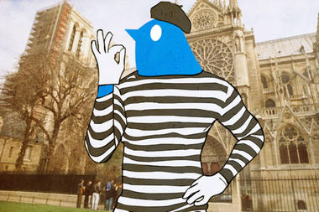
    - Rooster + beret=>**French Chauvinism**
    - Stiff behavior, skin tight t-shirt => **Feminism and Court Society**
    - (Actually the rooster is the Twitter Bird)
  + Do you think it is normal to ban these words because of “distortion of competition” ? Do you think we should still fight against “distortion of competition” in media ?